Adaptation of Vision Foundation Models for Knee Osteoarthritis Classification
Jonah Belback
1. PURPOSE
[why important]

2. METHODS
2.1 Dataset
[about dataset]

2.2 The Proposed Model Architecture
Figure 1 shows the overall model structure where DinoV2, or rather ViT, is used as a backbone to extract features from out input images. These features are then given to an MLP as a classification head for a binary label decided by a threshold of 0.5 on the confidence percentage that the input image is [----]
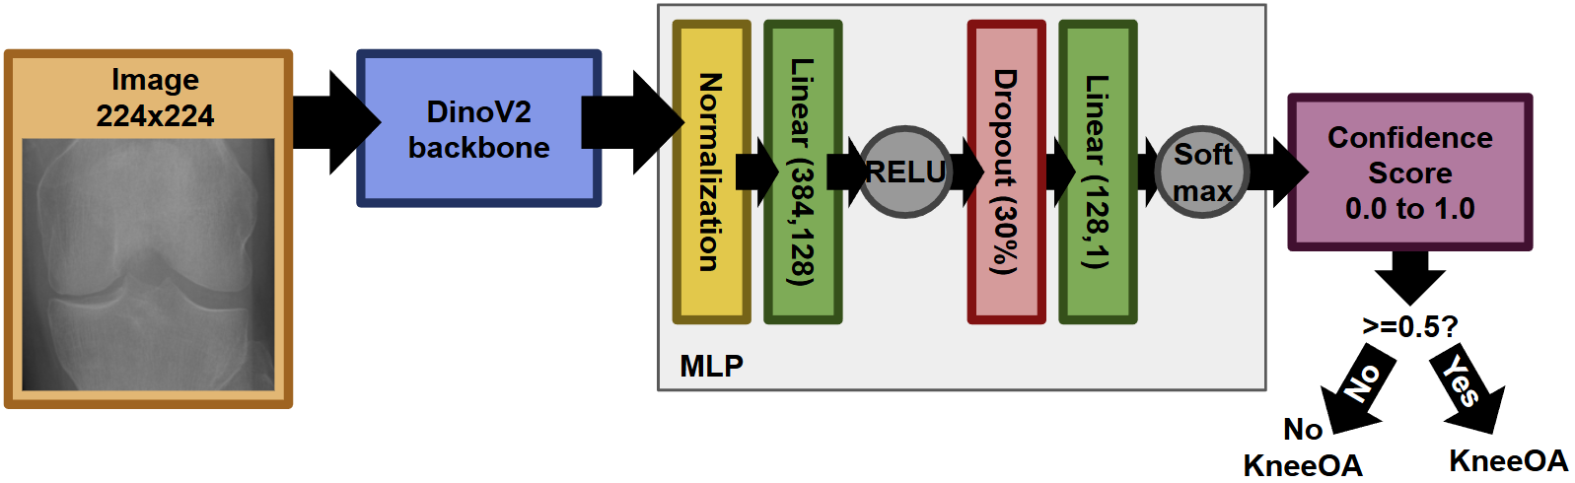
Figure 1. Architecture of the proposed machine learning structure for predicting [------].

2.4 Evaluation
[how it is evaluated]
[why metric is important]
[that we did finetuning and no finetuning]
A

2.3 Experiments
The best learning rate to use for the model architecture was found by evaluating the model at a 70% training split, batch size of 16, epoch of 15, and then from 0.1 to 0.0000001 by steps of 10. This was done separately for both finetuning and not finetuning DinoV2. The results of these can be found in Table 1, where it was decided to go ahead with the standard learning rate of 1e-6 for without-finetuning and 1e-5 for with-finetuning from overall best performance across all metrics.
Table 1. Evaluation of learning rate to use as a standard. Metrics evaluated from on a separate 15% testing data split
 | Learning Rate | AUC | Accuracy | Macro-F1 | Precision |  | Recall |  | F1-score
 |  |  |  |  | Knee OA | No Knee OA | Knee OA | No Knee OA | Knee OA | No Knee OA
No Finetuning  DinoV2 | 0.1 | 0.500 | 0.29 | 0.225 | 0.23 | 0 | 1.00 | 0 | 0.45 | 0
 | 0.01 | 0.500 | 0.29 | 0.225 | 0.29 | 0 | 1.00 | 0 | 0.45 | 0
 | 0.001 | 0.500 | 0.27 | 0.215 | 0.27 | 0 | 1.00 | 0 | 0.43 | 0
 | 0.0001 | 0.520 | 0.32 | 0.255 | 0.30 | 0.92 | 0.99 | 0.05 | 0.46 | 0.09
 | 0.00001 | 0.956 | 0.98 | 0.965 | 1.00 | 0.97 | 0.91 | 1.00 | 0.95 | 0.98
 | 0.000001 | 0.967 | 0.96 | 0.950 | 0.87 | 1.00 | 0.99 | 0.94 | 0.93 | 0.97
 | 0.0000001 | 0.926 | 0.95 | 0.940 | 0.96 | 0.95 | 0.87 | 0.98 | 0.91 | 0.97
Finetuning  DinoV2 | 0.1 | 0.500 | 0.29 | 0.225 | 0.29 | 0 | 1.00 | 0 | 0.45 | 0
 | 0.01 | 0.500 | 0.29 | 0.225 | 0.29 | 0 | 1.00 | 0 | 0.45 | 0
 | 0.001 | 0.500 | 0.32 | 0.245 | 0.32 | 0 | 1.00 | 0 | 0.49 | 0
 | 0.0001 | 0.537 | 0.63 | 0.545 | 0.35 | 0.74 | 0.36 | 0.73 | 0.35 | 0.74
 | 0.00001 | 0.981 | 0.99 | 0.980 | 0.98 | 0.99 | 0.97 | 0.99 | 0.97 | 0.99
 | 0.000001 | 0.965 | 0.98 | 0.970 | 0.99 | 0.97 | 0.93 | 1.00 | 0.96 | 0.98
 | 0.0000001 | 0.932 | 0.96 | 0.945 | 0.98 | 0.94 | 0.87 | 0.99 | 0.92 | 0.97

3. RESULTS
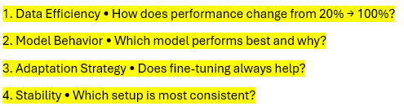
Table 2 Shows the effect of data availability and how it impacts performance. Overall as the amount of data increases, so does the performance. This is because as the model gets more and more data, it is introduced to new cases it hasn’t seen before and becomes more generalizable to said data. With smaller amounts of data there is also the possibility of overfitting to a bias present in your small sample that will affect your performance to unseen data
Models with a frozen DinoV2 backbone were worse compared to models that did finetuning. Although the performance can be considered comparable in many metrics, especially when there isn’t much to improve with such high scores, finetuning always lead to a higher AUC.
The best model overall is a finetuned DinoV2 on a learning rate of 1e-5, with a batch size of 16, and given as much data as possible.
In terms of consistency in setup, it was a simple toggle, and neither is more inconsistent than the other.
Table 2. Results of model on its training data when the amount of training data shifts. Ran with batch size of 16, epoch of 20, and the optimal learning rate found previous. Metrics are evaluated from the same set of data used to train.
 | Amount of Data | AUC | Accuracy | Macro-F1 | Precision |  | Recall |  | F1-score
 |  |  |  |  | Knee OA | No Knee OA | Knee OA | No Knee OA | Knee OA | No Knee OA
No Finetuning  DinoV2 | 20% | 0.961 | 0.97 | 0.965 | 0.97 | 0.97 | 0.94 | 0.99 | 0.95 | 0.98
 | 50% | 0.968 | 0.98 | 0.970 | 0.97 | 0.98 | 0.95 | 0.99 | 0.96 | 0.98
 | 70% | 0.969 | 0.98 | 0.980 | 0.99 | 0.98 | 0.94 | 1.00 | 0.97 | 0.99
 | 100% | 0.928 | 0.93 | 0.920 | 0.86 | 0.97 | 0.92 | 0.93 | 0.89 | 0.95
Finetuning  DinoV2 | 20% | 0.931 | 0.95 | 0.945 | 0.98 | 0.94 | 0.87 | 0.99 | 0.92 | 0.97
 | 50% | 0.963 | 0.97 | 0.960 | 0.93 | 0.98 | 0.96 | 0.97 | 0.94 | 0.98
 | 70% | 0.983 | 0.98 | 0.980 | 0.96 | 0.98 | 0.98 | 0.98 | 0.97 | 0.99
 | 100% | 0.926 | 0.93 | 0.915 | 0.85 | 0.97 | 0.92 | 0.94 | 0.88 | 0.95

Table 3. Results of model on unseen data when the amount of training data shifts. Ran with batch size of 16, epoch of 20, and the optimal learning rate found previous. Metrics are evaluated from a separated split of unseen data.
 | Split of Data | AUC | Accuracy | Macro-F1 | Precision |  | Recall |  | F1-score
 |  |  |  |  | Knee OA | No Knee OA | Knee OA | No Knee OA | Knee OA | No Knee OA
No Finetuning  DinoV2 | 20% | 0.961 | 0.97 | 0.965 | 0.97 | 0.97 | 0.94 | 0.99 | 0.95 | 0.98
 | 30%
 | 40%
 | 50% | 0.968 | 0.98 | 0.970 | 0.97 | 0.98 | 0.95 | 0.99 | 0.96 | 0.98
 | 60%
 | 70% | 0.969 | 0.98 | 0.980 | 0.99 | 0.98 | 0.94 | 1.00 | 0.97 | 0.99
 | 80%
 | 90%
 | 98% | 0.928 | 0.93 | 0.920 | 0.86 | 0.97 | 0.92 | 0.93 | 0.89 | 0.95
Finetuning  DinoV2 | 20% | 0.931 | 0.95 | 0.945 | 0.98 | 0.94 | 0.87 | 0.99 | 0.92 | 0.97
 | 30%
 | 40%
 | 50% | 0.963 | 0.97 | 0.960 | 0.93 | 0.98 | 0.96 | 0.97 | 0.94 | 0.98
 | 60%
 | 70% | 0.983 | 0.98 | 0.980 | 0.96 | 0.98 | 0.98 | 0.98 | 0.97 | 0.99
 | 80%
 | 90%
 | 98% | 0.926 | 0.93 | 0.915 | 0.85 | 0.97 | 0.92 | 0.94 | 0.88 | 0.95

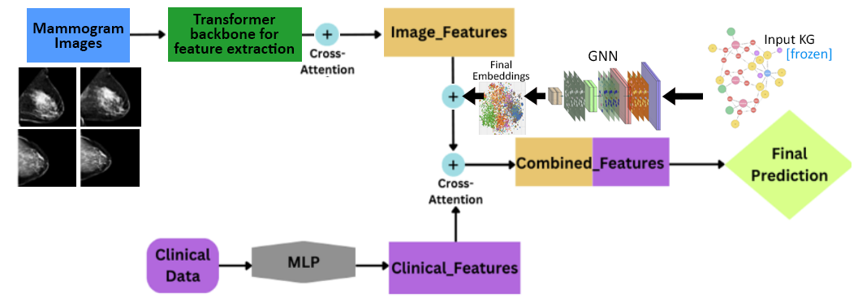
Figure 2a,b,c. The Confusion matrix (left, a), The Loss Curve (middle, b), The ROC Curve (right, c); from the model with a datasplit of 20%, not going through finetuning of DinoV2; also referenced in Table 2.

Figure 3a,b,c. The Confusion matrix (left, a), The Loss Curve (middle, b), The ROC Curve (right, c); from the model with a datasplit of 50%, not going through finetuning of DinoV2; also referenced in Table 2.

Figure 4a,b,c. The Confusion matrix (left, a), The Loss Curve (middle, b), The ROC Curve (right, c); from the model with a datasplit of 70%, not going through finetuning of DinoV2; also referenced in Table 2.

Figure 5a,b,c. The Confusion matrix (left, a), The Loss Curve (middle, b), The ROC Curve (right, c); from the model with a datasplit of 100%, not going through finetuning of DinoV2; also referenced in Table 2.

4. DISCUSSION
In this study we [-----]

REFERENCES
[1] a

